1.BASICS

* select \* from cd.facilities
* select name,membercost from cd.facilities
* select \* from cd.facilities where membercost > 0
* select facid , name , membercost , monthlymaintenance from cd.facilities where membercost > 0 and membercost < monthlymaintenance/50
* select \* from cd.facilities where name like '%Tennis%'
* select \* from cd.facilities where facid in(1,5)
* select name ,

case

when monthlymaintenance > 100 then 'expensive'

else 'cheap'

end as cost from cd.facilities

* select memid , surname , firstname , joindate from cd.members where joindate > '2012-09-01'
* select distinct surname from cd.members order by surname limit 10
* select distinct surname from cd.members union all select name from cd.facilities
* select max(joindate) as latest from cd.members
* select firstname,surname,joindate from cd.members where joindate = (select max(joindate) from cd.members)

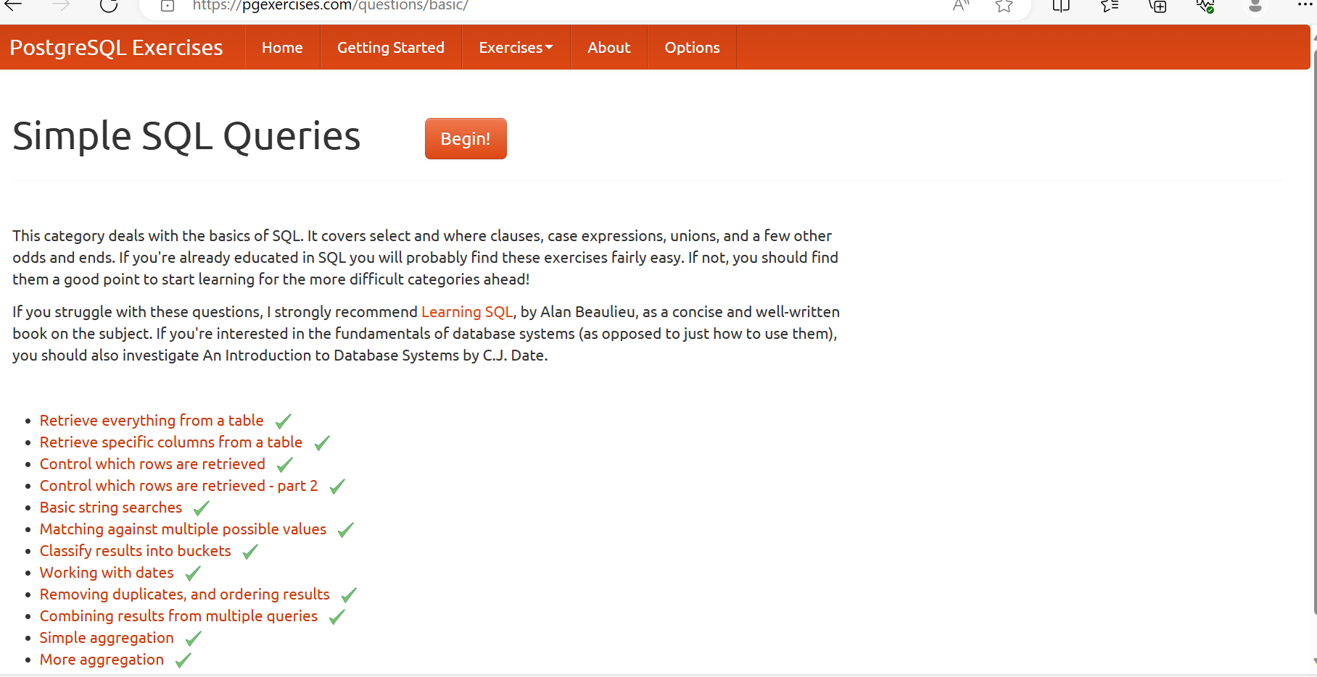

2.JOINS AND SUBQUERIES

* select starttime from cd.bookings cb join cd.members cm on cb.memid = cm.memid where cm.firstname = 'David' and cm.surname = 'Farrell'
* select starttime as start,name from cd.facilities cf join cd.bookings cb on cf.facid = cb.facid where cb.starttime >= '2012-09-21' and cb.starttime < '2012-09-22' and cf.name in ('Tennis Court 1' , 'Tennis Court 2') order by starttime
* select distinct cms.firstname , cms.surname from cd.members cm

join cd.members cms on cms.memid = cm.recommendedby order by surname, firstname

* select cm.firstname as memfname , cm.surname as memsname , rec.firstname as recfname ,rec.surname as recsname from cd.members cm left outer join cd.members rec on rec.memid = cm.recommendedby order by cm.surname , cm.firstname
* select distinct cm.firstname || ' ' || cm.surname as member, name as facility from cd.members cm join cd.bookings cb on cb.memid =cm.memid join cd.facilities cf on cb.facid = cf.facid where cf.name in ('Tennis Court 1' ,'Tennis Court 2') order by member,facility
* select cm.firstname || ' ' || cm.surname as member, cf.name as facility,

case

when cm.memid = 0 then

cb.slots\*cf.guestcost

else

cb.slots\*cf.membercost

end as cost

from cd.members cm inner join cd.bookings cb on cm.memid = cb.memid

inner join cd.facilities cf on cb.facid = cf.facid

where cb.starttime >= '2012-09-14' and cb.starttime < '2012-09-15' and

((cm.memid = 0 and cb.slots\*cf.guestcost > 30) or

(cm.memid != 0 and cb.slots\*cf.membercost > 30))

order by cost desc

* select distinct cm.firstname || ' ' || cm.surname as member,(select rec.firstname || ' ' || rec.surname as recommender from cd.members rec where rec.memid = cm.recommendedby) from cd.members cm order by member
* select member, facility, cost from (select cm.firstname || ' ' || cm.surname as member,cf.name as facility,

case

when cm.memid = 0 then

cb.slots\*cf.guestcost

else

cb.slots\*cf.membercost

end as cost

from cd.members cm inner join cd.bookings cb on cm.memid = cb.memid

inner join cd.facilities cf on cb.facid = cf.facid

where cb.starttime >= '2012-09-14' and cb.starttime < '2012-09-15')as bookings

where cost > 30

order by cost desc

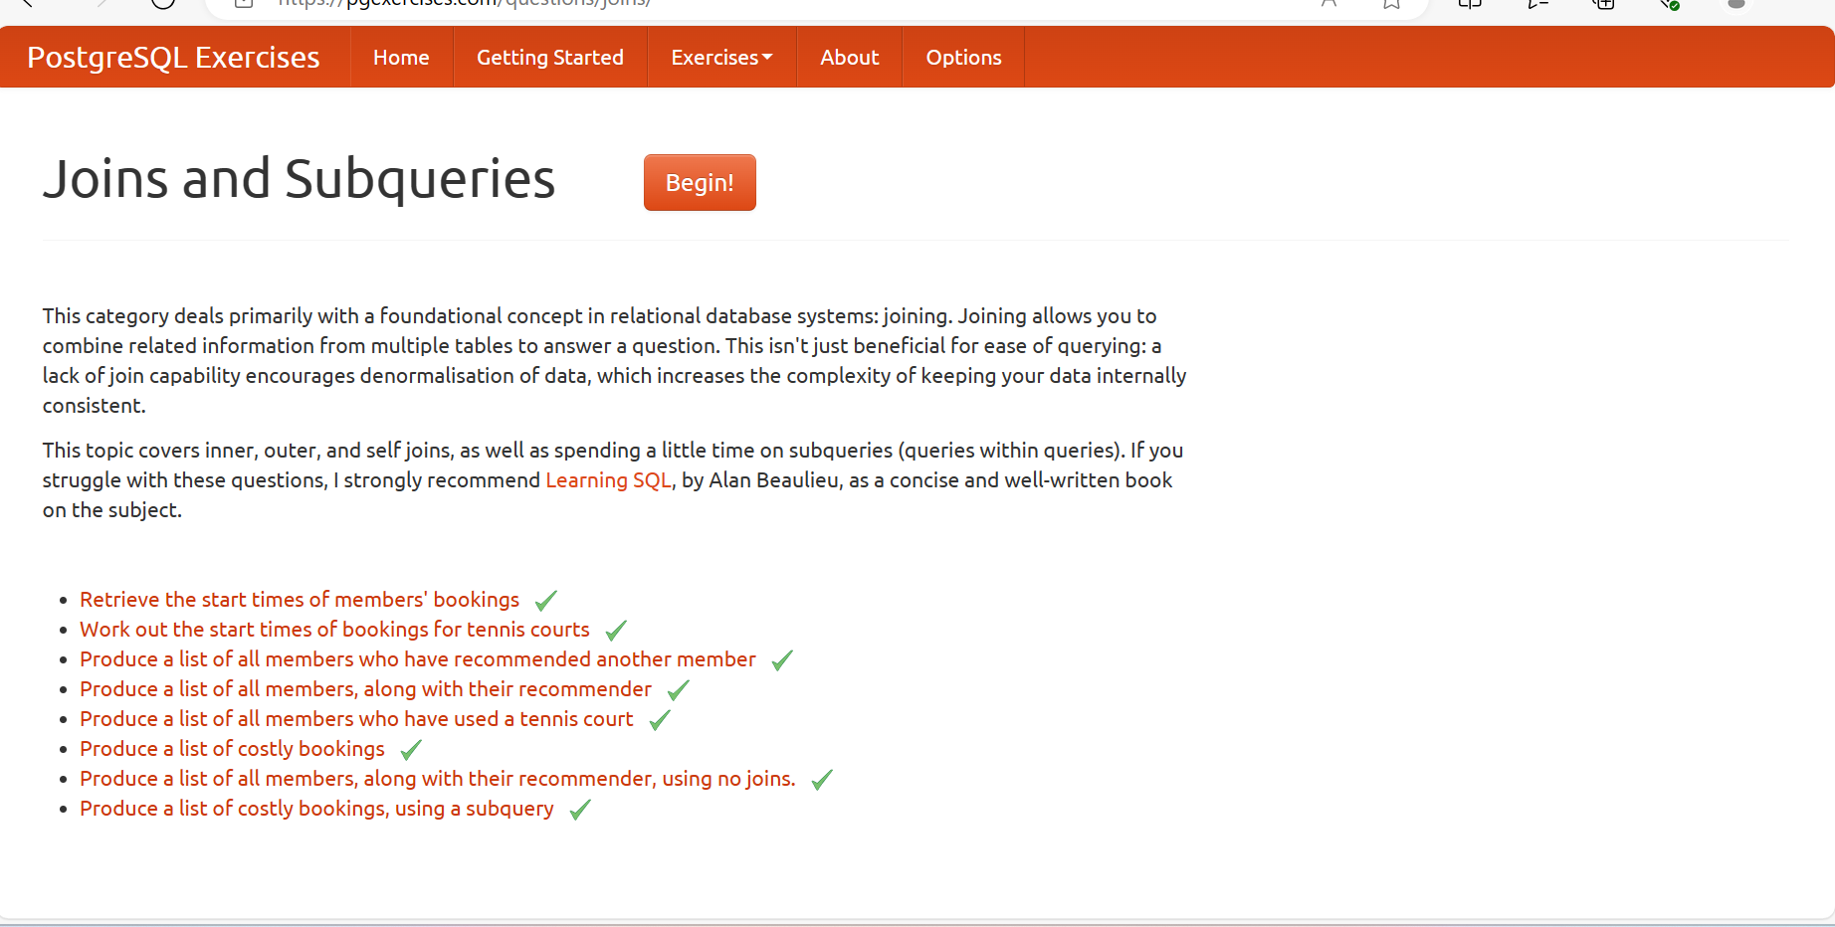

3.MODIFYING DATA

* insert into cd.facilities(facid,name,membercost,guestcost,initialoutlay,monthlymaintenance) values(9,'Spa',20,30,100000,800)
* insert into cd.facilities(facid, name, membercost, guestcost, initialoutlay, monthlymaintenance)

values(9, 'Spa', 20, 30, 100000, 800),

(10, 'Squash Court 2', 3.5, 17.5, 5000, 80)

* Insert into cd.facilities(facid, name, membercost, guestcost, initialoutlay, monthlymaintenance) select (select max(facid) from cd.facilities)+1,'Spa', 20, 30, 100000, 800
* update cd.facilities set initialoutlay = 10000 where facid = 1
* update cd.facilities set membercost = 6,guestcost = 30 where facid in (0,1)
* update cd.facilities

set

membercost = (select membercost \* 1.1 from cd.facilities where facid = 0),

guestcost = (select guestcost \* 1.1 from cd.facilities where facid = 0)

where facid = 1

* Delete from cd.bookings
* Delete from cd.members where memid = 37
* delete from cd.members where memid not in (select memid from cd.bookings)

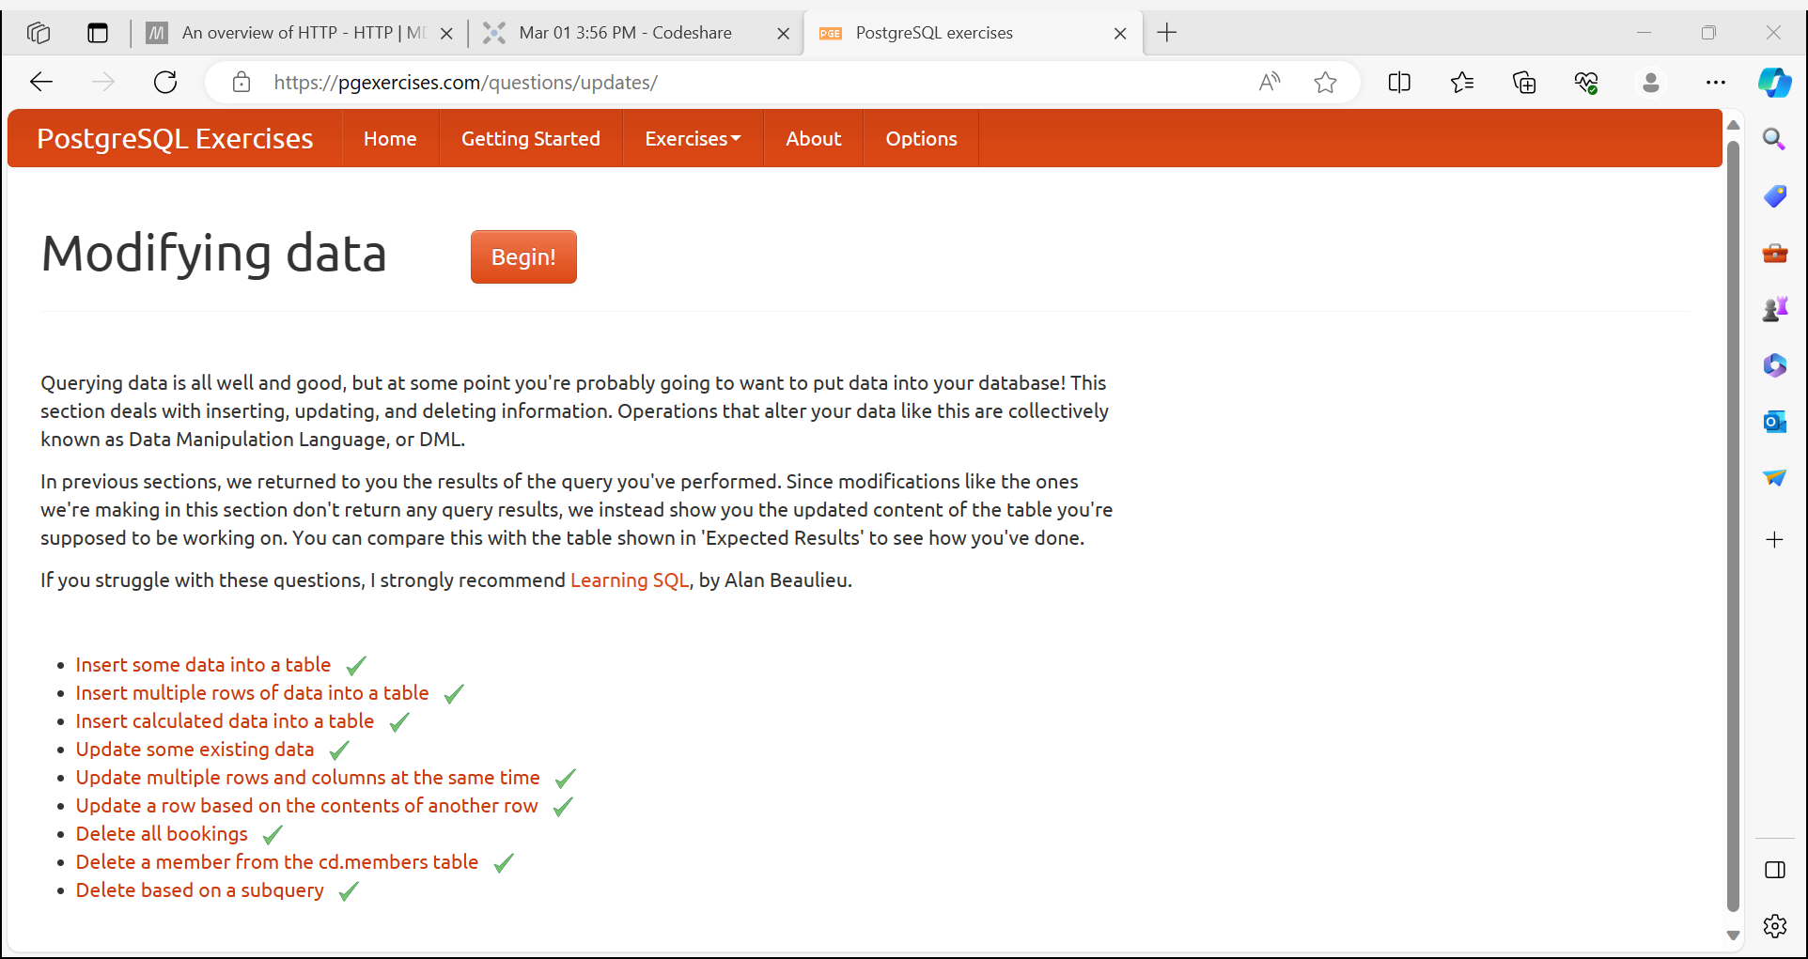

4.STRING OPERATIONS

* select surname || ', ' || firstname as name from cd.members
* select \* from cd.facilities where name like 'Tennis%'
* select \* from cd.facilities where name ilike 'TENNIS%'
* select memid,telephone from cd.members where telephone ~ '[()]'
* select lpad(cast(zipcode as char(5)),5,'0') as zip from cd.members order by zipcode
* select substr (surname,1,1) as letter, count(\*) as count from cd.members

group by letter order by letter

* select memid,translate(telephone, '-() ','') as telephone from cd.members order by memid

